Kafka Setup in Ubuntu with MQTT

Step 1. Install Java
1. Install Java Open jdk 8
sudo apt-get update

2. Make sure your system is using the correct JDK:
java -version

Step 2. Install Zookeeper
sudo apt-get install zookeeperd
we will now check if Zookeeper is alive
telnet localhost 2181
Back ground run : sudo telnet localhost 2181 &

at Telnet prompt, we will enter
ruok
(are you okay) if it’s all okay it will end telnet session and reply with
imok

Step 3. Install Kafka
Download Kafka
sudo wget https://archive.apache.org/dist/kafka/0.10.0.0/kafka_2.11-0.10.0.0.tgz
sudo mkdir /opt/kafka

sudo tar -xvzf kafka_2.11-0.10.0.0.tgz --directory /opt/kafka --strip-components 1

Step 4. Configuring Kafka Server
Kafka persists data to disk so we will now make a directory for it.
sudo mkdir /var/lib/kafka
sudo mkdir /var/lib/kafka/data
open /opt/kafka/config/server.properties in your favourite editor.
sudo nano /opt/kafka/config/server.properties
By default, Kafka doesn’t allow us to delete topics. To be able to delete topics, find the line and change it.
delete.topic.enable = true
next, we will change log directory
log.dirs=/var/lib/kafka/data
Kafka auto-deletes oldest logs after a time or after logs reach a certain size. To adjust it according to the time, change the line below.
log.retention.hours=168 #other accepted keys are(log.retention.ms, log.retention.minutes)
Or according to disk size.
log.retention.bytes=104857600

Step 5. Install Mosquitto
Ubuntu 16.04 has a recent version of Mosquitto in its default software repository. Log in with your non-root user and install Mosquitto with apt-get.
sudo apt-get install mosquitto mosquitto-clients

Step 6. Apache Kafka Connect MQTT Source

Download the Apache Kafka Connect MQTT binary and dependency

Download kafka MQTT file though below link

Wget “https://howtoprogram.xyz/wp-content/uploads/2016/07/kafka-mqtt-bin.zip”

unzip file

sudo apt install unzip
sudo unzip kafka-mqtt-bin.zip

Step 7. Using Apache Kafka Connect MQTT
Assume that the Apache Kafka is installed at: /opt/kafka

Step 8. Copy Kafka Connect MQTT library and dependency to the Kafka distribution.
Copy to /opt/kafka/libs below files:
kafka-connect-mqtt-1.0-SNAPSHOT.jar
org.eclipse.paho.client.mqttv3-1.0.2.jar
sudo mv kafka-connect-mqtt-1.0-SNAPSHOT.jar org.eclipse.paho.client.mqttv3-1.0.2.jar /opt/kafka/libs

Step 9. Create configuration file for Kafka MQTT connector
In the /opt/kafka/libs, create an mqtt.properties with following content:
In Project for workdone change the mqtt properties code below

name=mqtt
connector.class=com.evokly.kafka.connect.mqtt.MqttSourceConnector
tasks.max=1

kafka.topic=workdone
mqtt.client_id=mqtt-kafka-123456789

mqtt.clean_session=true
mqtt.connection_timeout=30
mqtt.keep_alive_interval=60

mqtt.server_uris=tcp://localhost:1883
mqtt.topic=workdonemqtt

Step 10. Make sure your MQTT broker be ready

Step 11. Start Apache Kafka server

We first change directory to the Apache Kafka installation folder.
cd /opt/kafka

Step 12. Start ZooKeeper

./bin/zookeeper-server-start.sh config/zookeeper.properties &

Step 13. Start Kafka Server

./bin/kafka-server-start.sh config/server.properties &

Step 14. Start the Apache Kafka Connect MQTT source

Issue the following command and wait

./bin/connect-standalone.sh config/connect-standalone.properties config/mqtt.properties
(OR)
Back ground run
./bin/connect-standalone.sh config/connect-standalone.properties config/mqtt.properties &

Step 15. In another terminal create a topic

/opt/kafka/bin/kafka-topics.sh --create --zookeeper localhost:2181 --replication-factor 1 --partitions 1 --topic workdone

List all topics with the command below and it will print test the topic we just created

/opt/kafka/bin/kafka-topics.sh --list --zookeeper localhost:2181

Step 16. Let’s start publishing messages on workdone topic

/opt/kafka/bin/kafka-console-producer.sh --broker-list localhost:9092 --topic workdone

Step 17. We will now create a subscriber on workdone topic and listen from the beginning of the topic.
Open Another Terminal

/opt/kafka/bin/kafka-console-consumer.sh --bootstrap-server localhost:9092 --topic workdone --from-beginning --zookeeper localhost:2181 &

Enter some message in the producer
Hello world!!!
You will see the messages appearing on the subscriber terminal.

Ref Kafka Installation Links:
https://hevodata.com/blog/how-to-install-kafka-on-ubuntu/
https://howtoprogram.xyz/2016/07/30/apache-kafka-connect-mqtt-source-tutorial/

Mosquitto link:
https://www.digitalocean.com/community/tutorials/how-to-install-and-secure-the-mosquitto-mqtt-messaging-broker-on-ubuntu-16-04

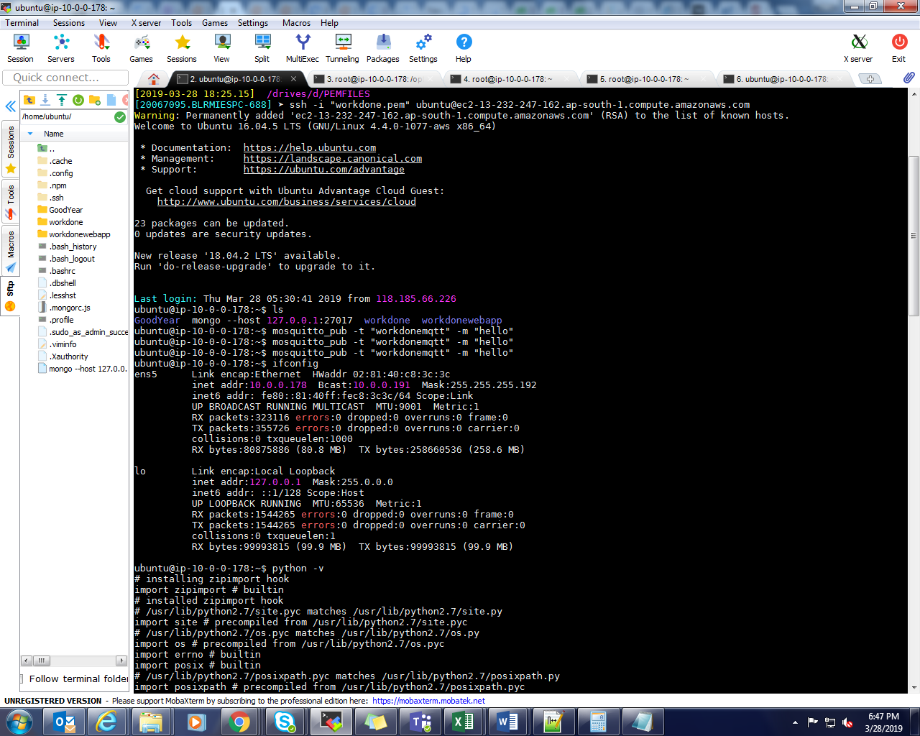

Imp Point:
Start ZooKeeper

./bin/zookeeper-server-start.sh config/zookeeper.properties &
Start Kafka Server

./bin/kafka-server-start.sh config/server.properties &

./bin/connect-standalone.sh config/connect-standalone.properties config/mqtt.properties

/opt/kafka/bin/kafka-topics.sh --list --zookeeper localhost:2181

Notes:

copy mqtt.properties to /opt/kafka/ config also
cd /opt/kafka/libs/mqtt.properties /opt/kafka/ config
give full permissions for both files

cd /opt/kafka/libs
echo chmod 777 mqtt.properties
cd /opt/kafka/config

Java Deployment

Ubuntu @ : /Goodyear:
Java -jar wrokdone-0.0.1-SNAPSHOT.jar
Sudo nohup sh ava -jar wrokdone-0.0.1-SNAPSHOT.jar &

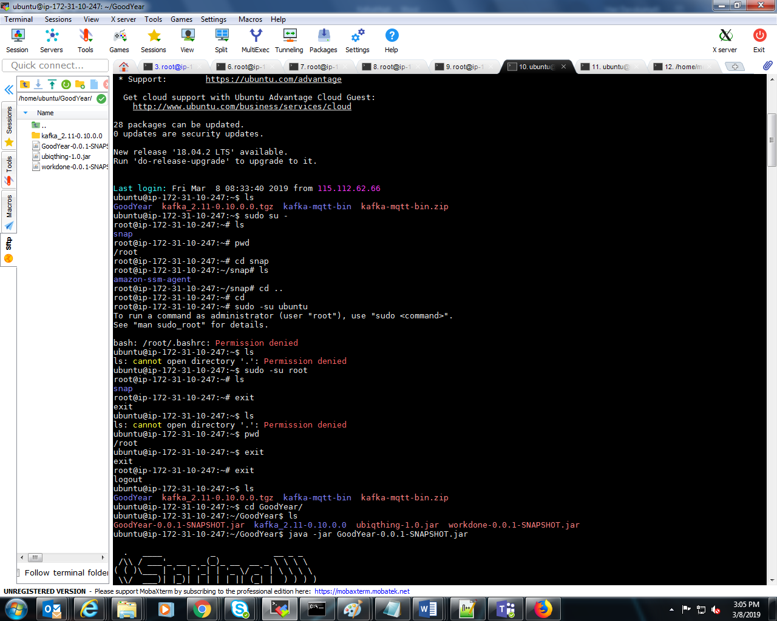

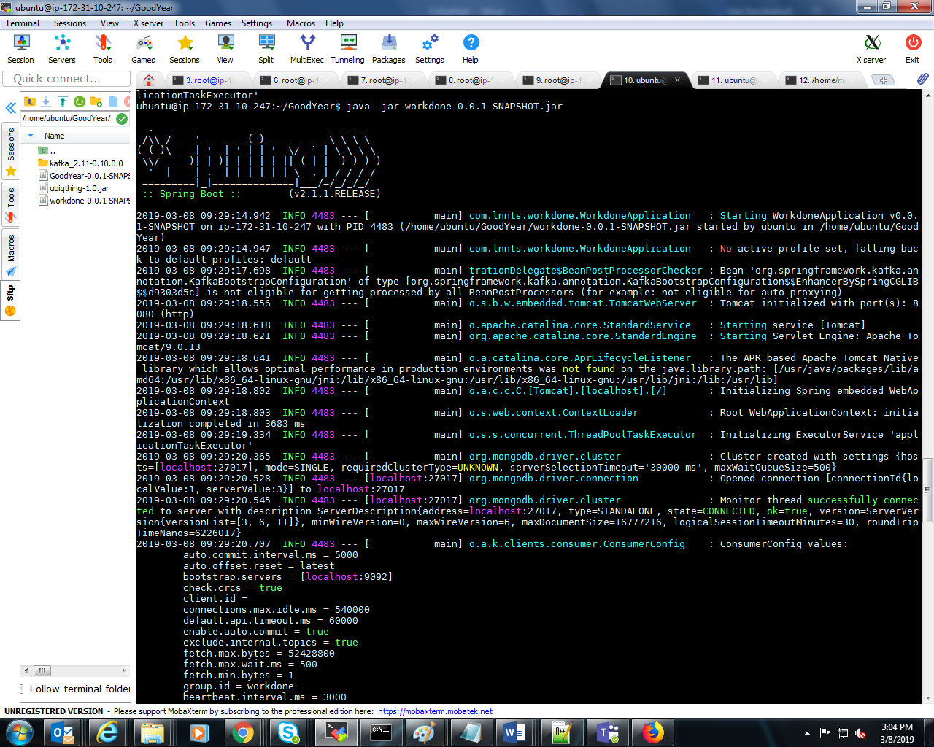

Sudo mongod
Sudo mongod status

Sudo mongod start

Sudo service mongod status

Sudo service mongod start
Sudo service mongod status

Sudo mongo -- host 127.0.0.1:27017

Ref Link: https://websiteforstudents.com/install-mongodb-on-ubuntu-16-04-lts-servers/

Installation mogo DB:
https://websiteforstudents.com/install-mongodb-on-ubuntu-16-04-lts-servers/

create a folder in Root:

/data/db
Mkdir data
Mkdir db

Ex:-
Root: mkdir hari
Hari/ mkdir db

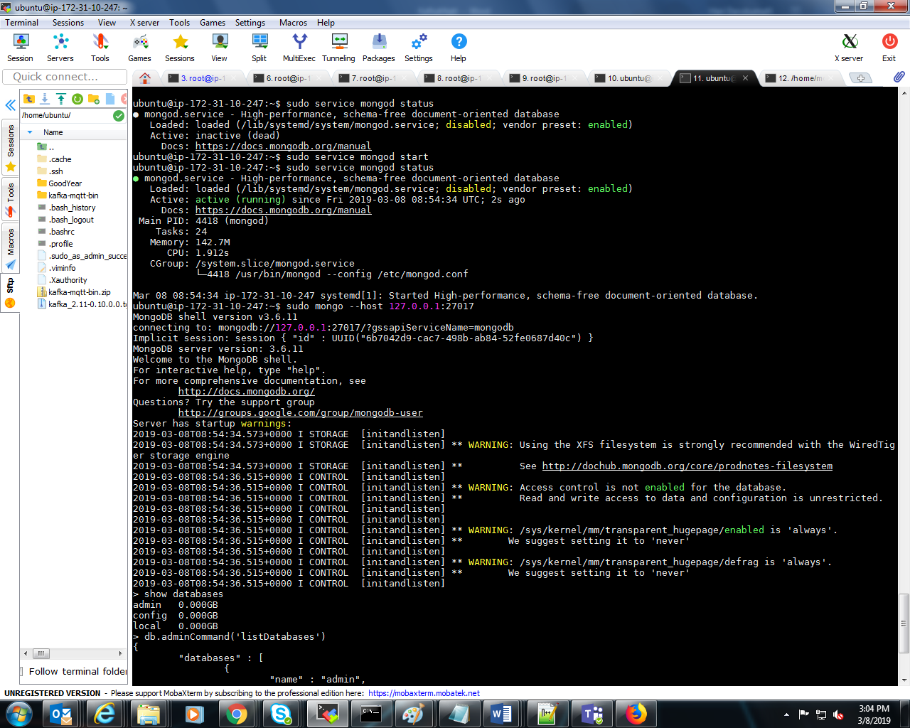

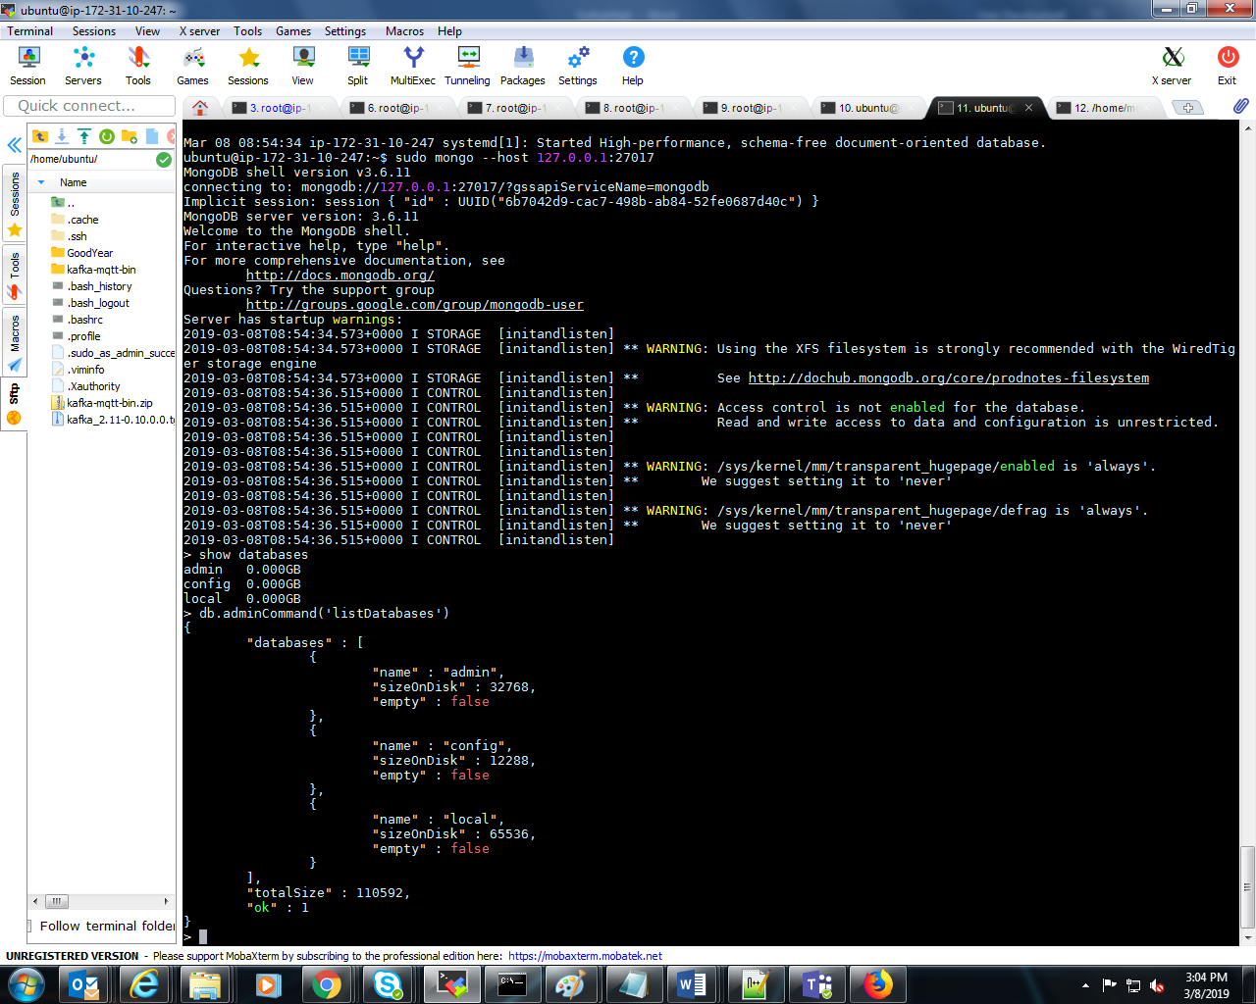

Other Images Final:

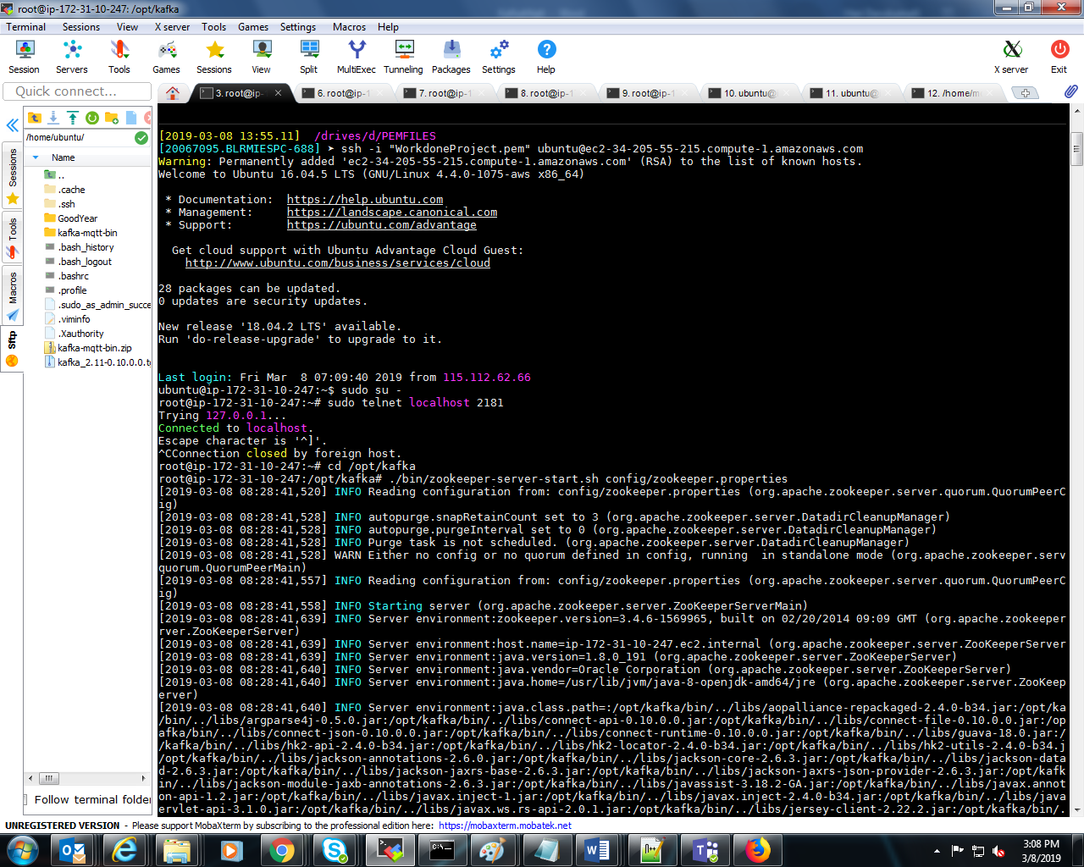

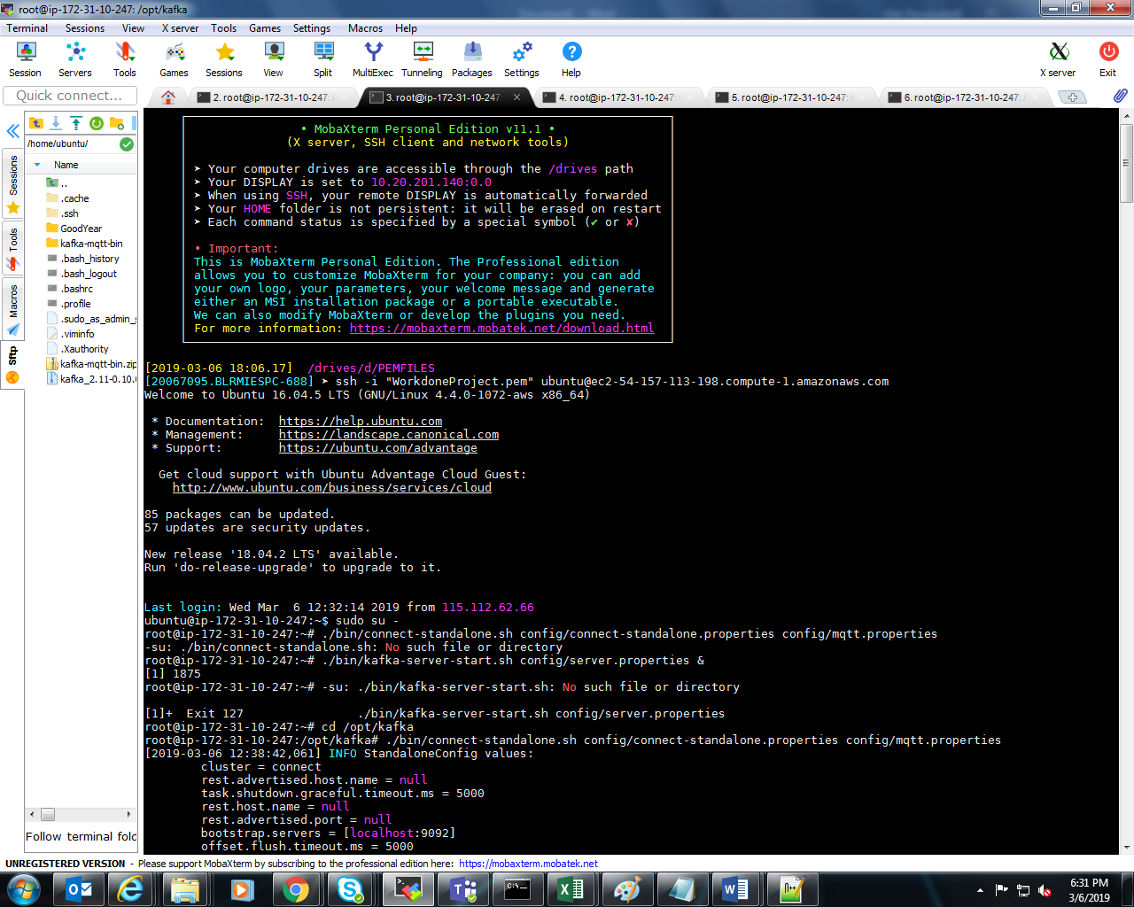
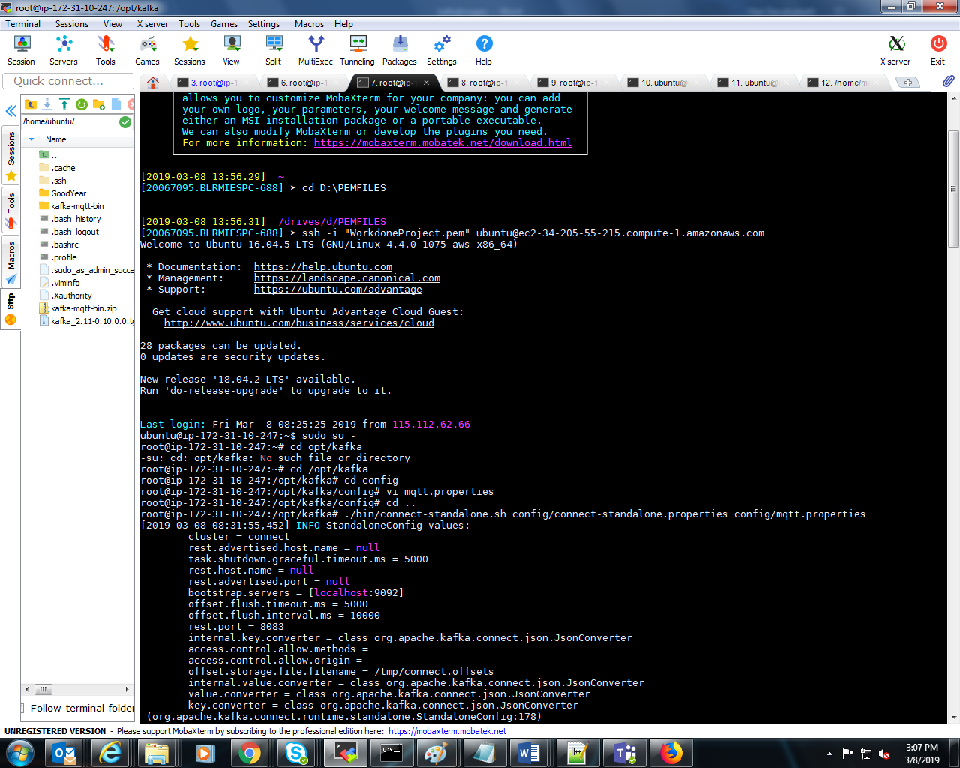
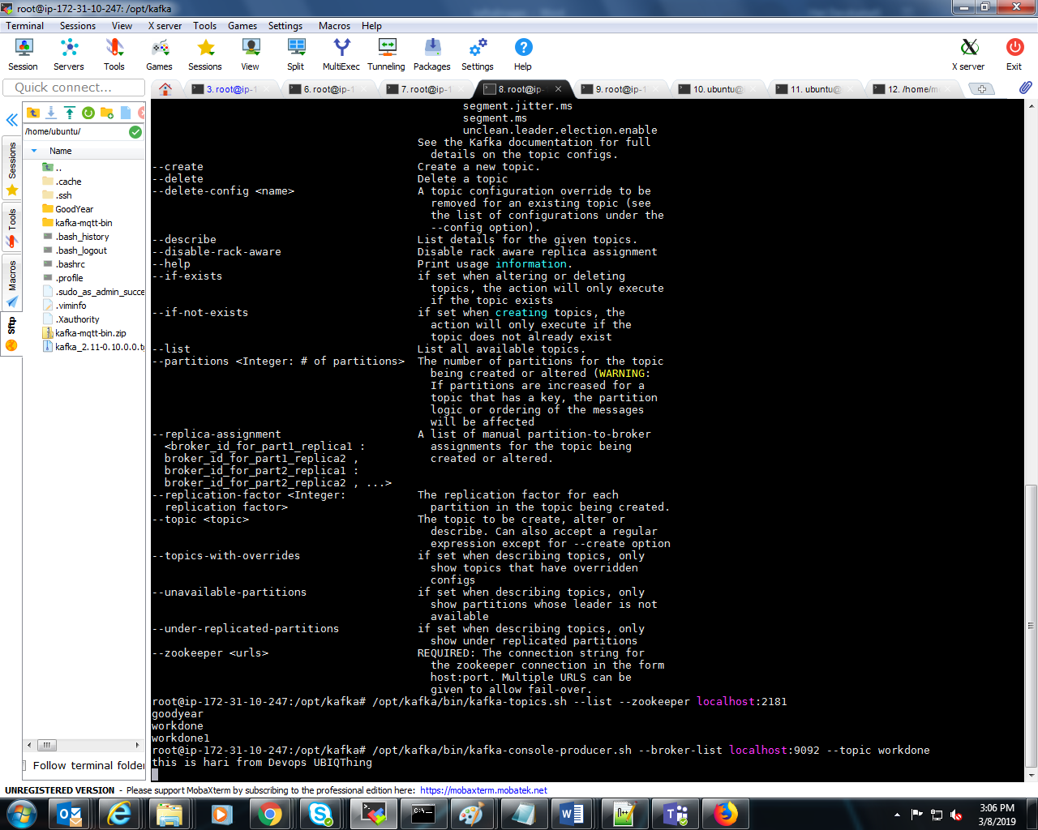

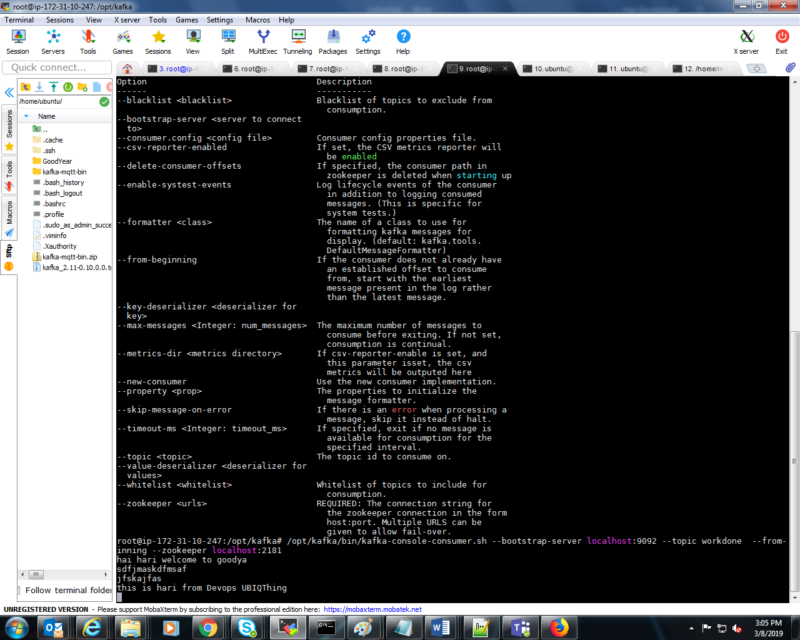

Node Js Installation
https://websiteforstudents.com/install-the-latest-node-js-and-nmp-packages-on-ubuntu-16-04-18-04-lts/

install angular js @ 1.7.4
https://cli.angular.io/

npm install -g @angular/cli

ng new workdone

cd workdone

ng serve
sudo nohup sh ng serve &

check the port working or not
http://localhost:4200/ *

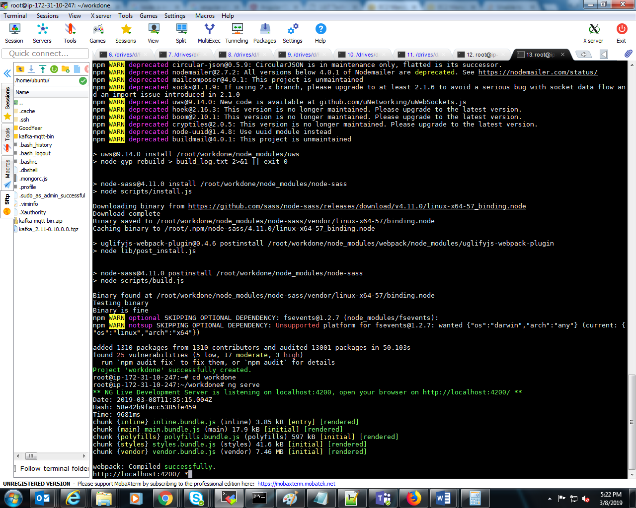

Work done Manage deployment :

D:\workdone\src\app\admin\components\adminhomepage\ adminhomepage.component.js
Open and change the IP Address of current pc (means where is deployed ).

machinedetailUrl='http://13.232.247.162:8080/workdone/machineactivity'

user name: workdone
Pwd :workdone@1234

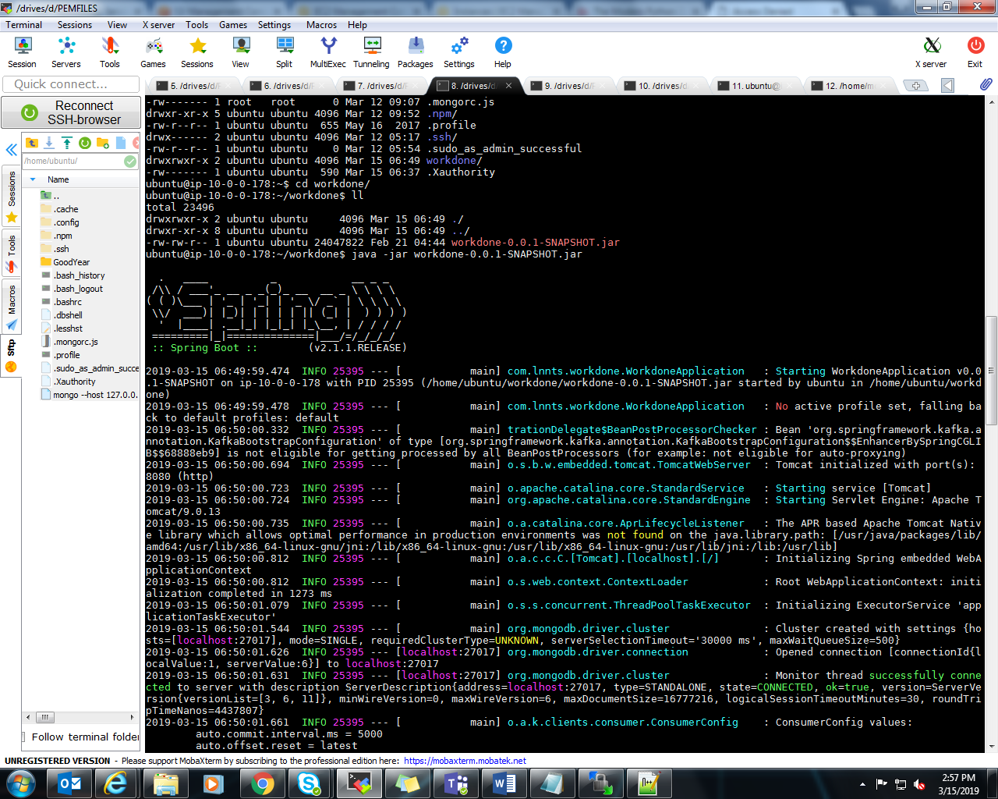
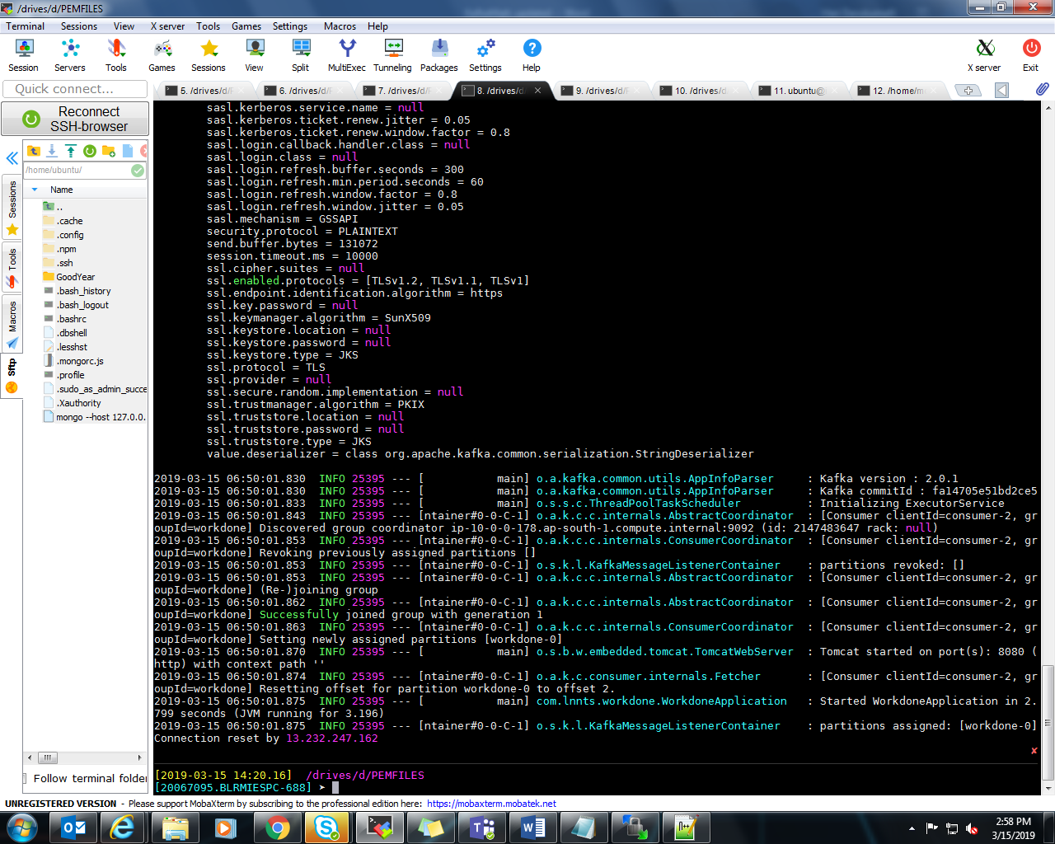

Mongo service check

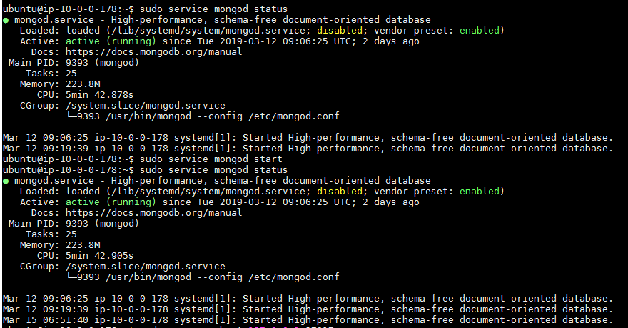

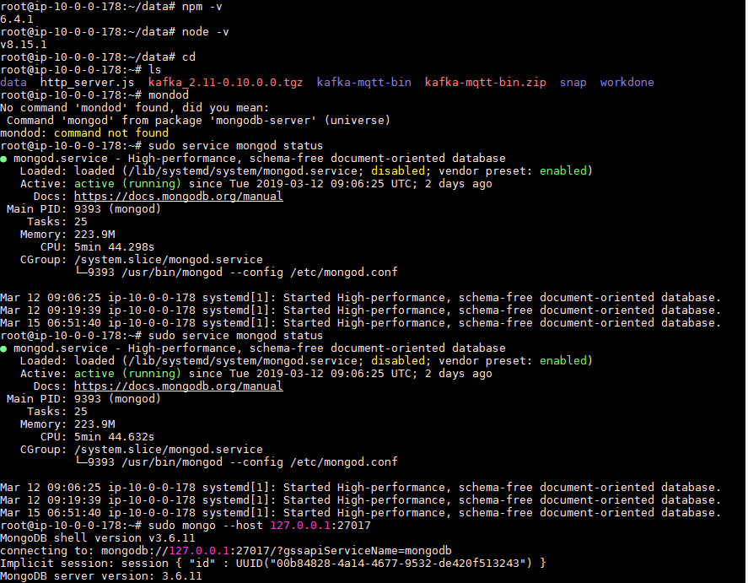

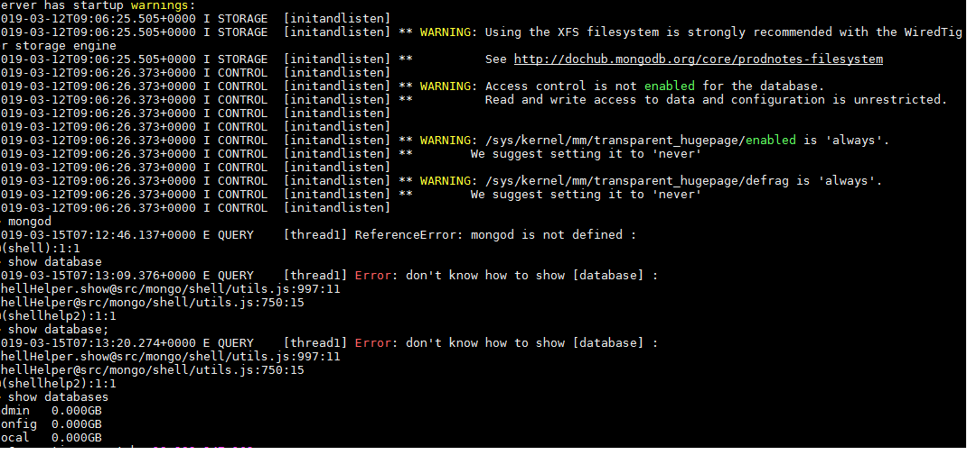

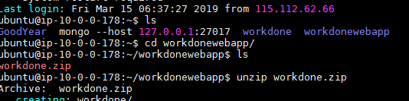

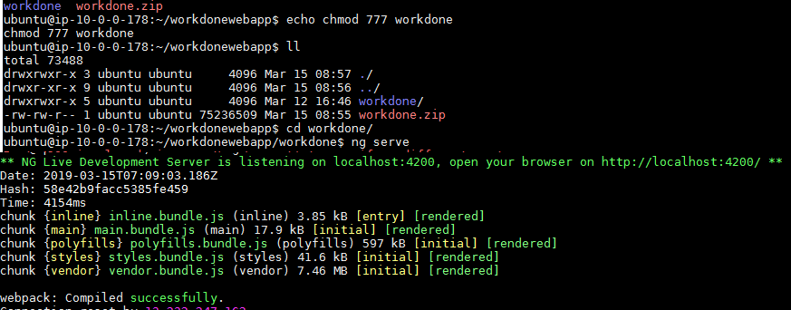

If port 4200 is already running kill the port and re-run ng serve

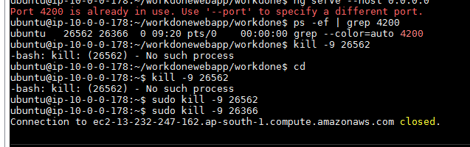
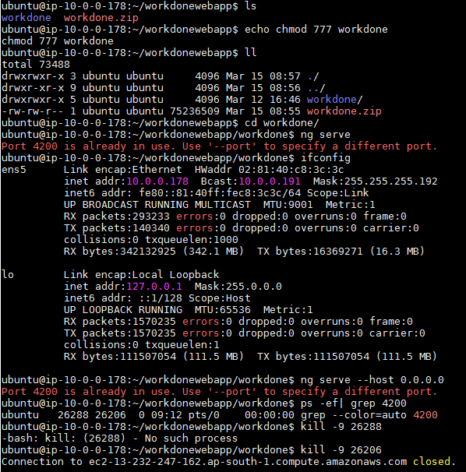

Note: - install npm before going to run ng serve

npm install

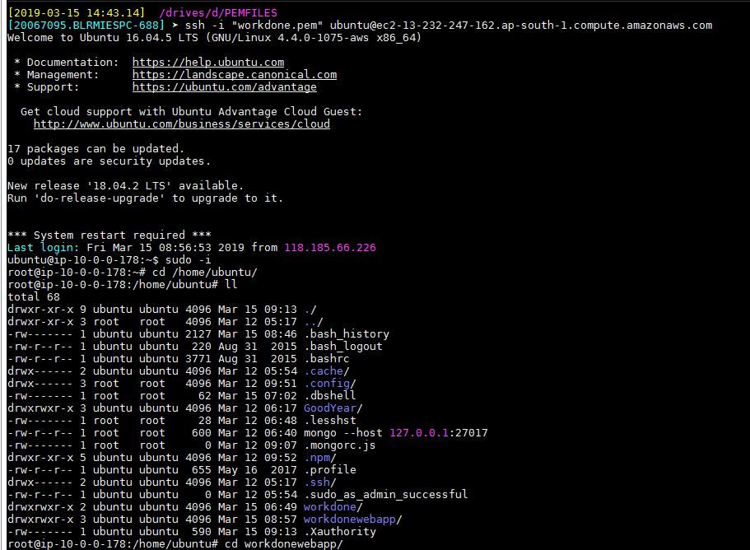

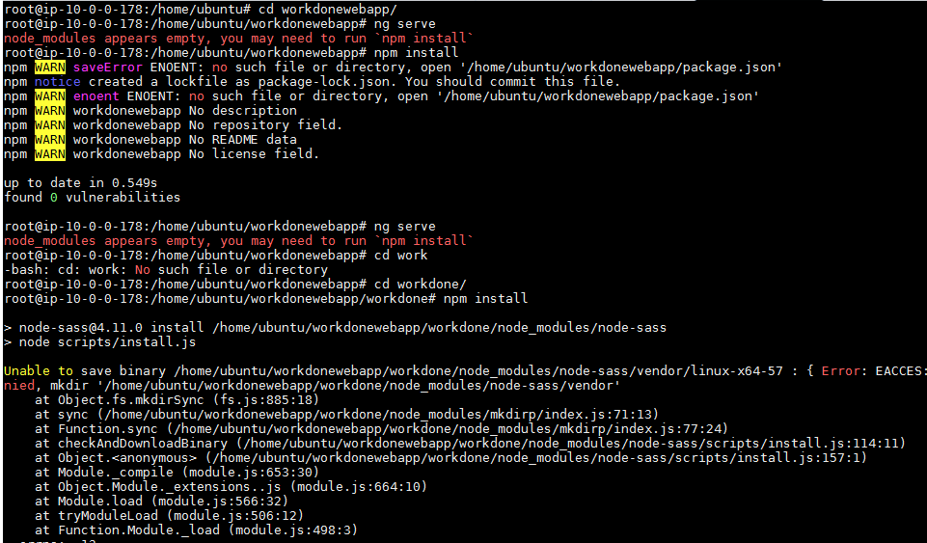

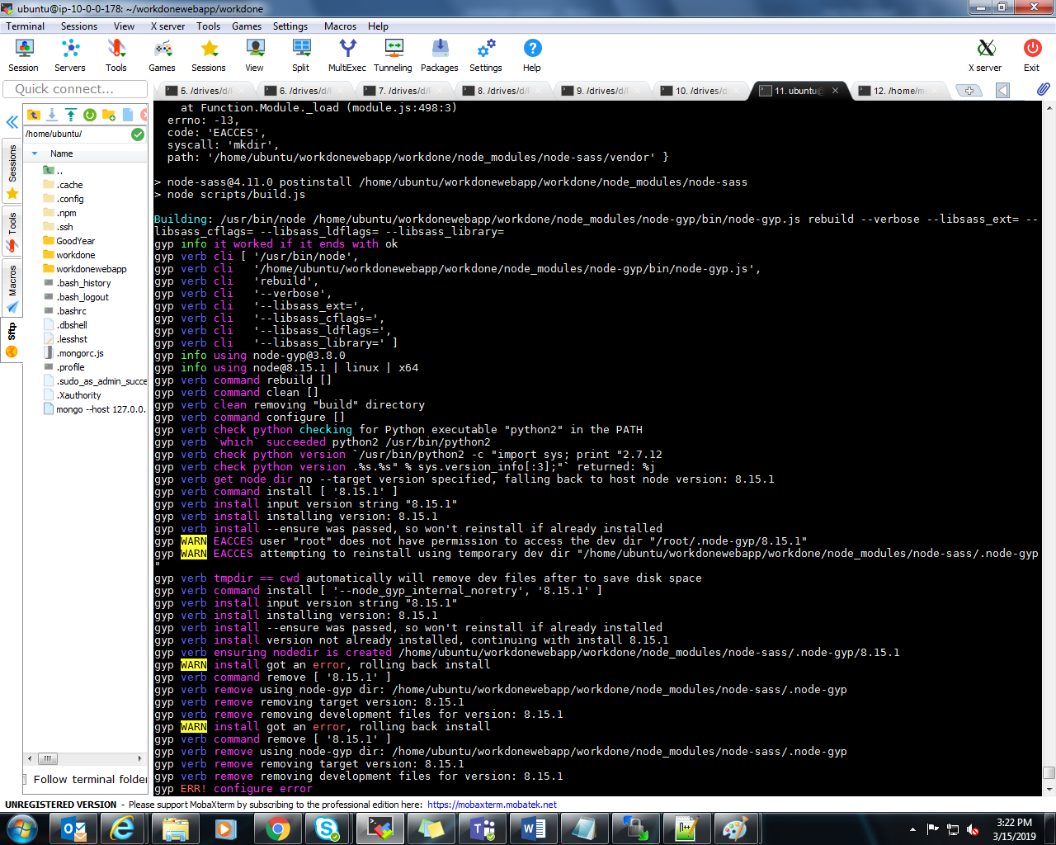

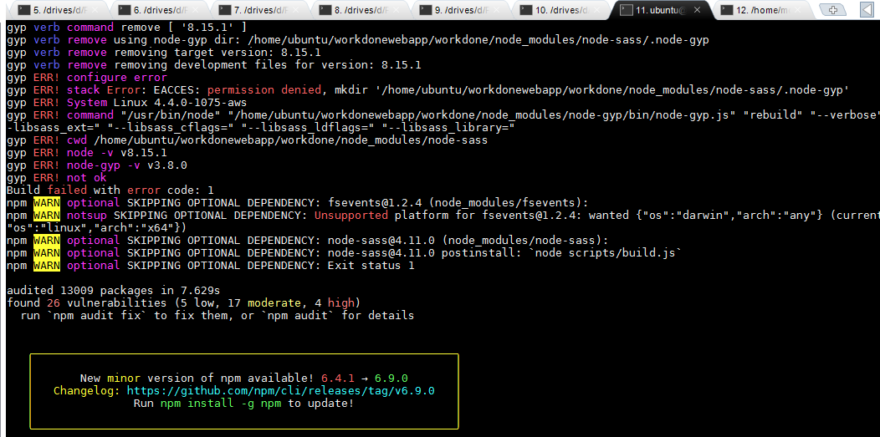

Install ng serve

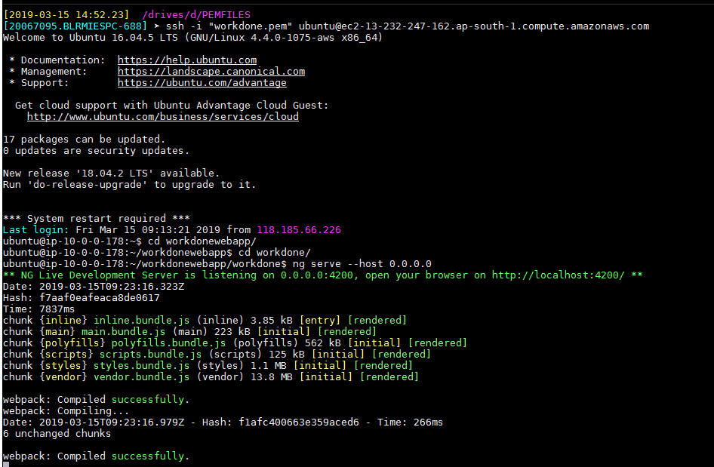

Errors like below,

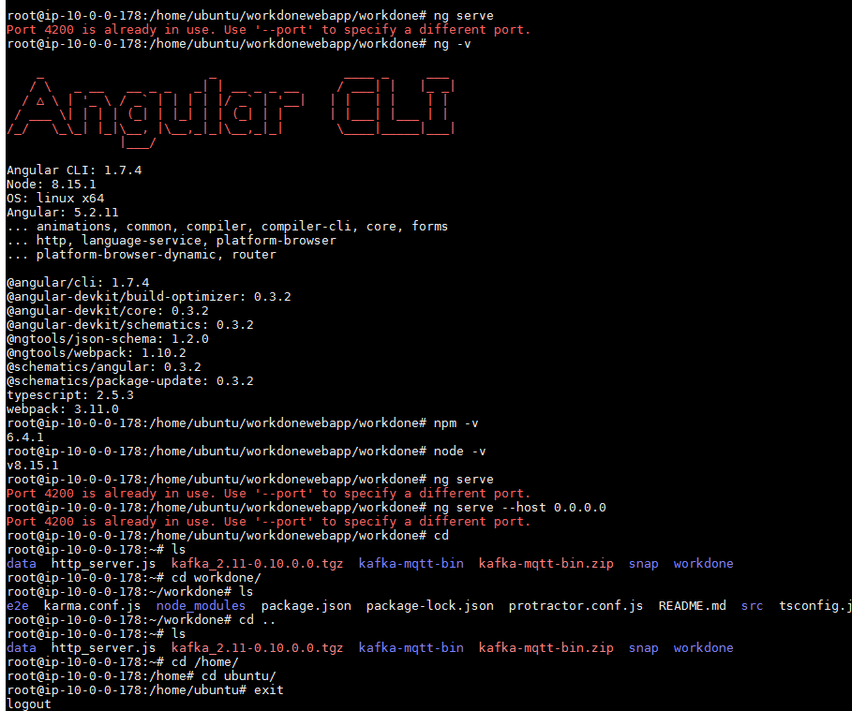

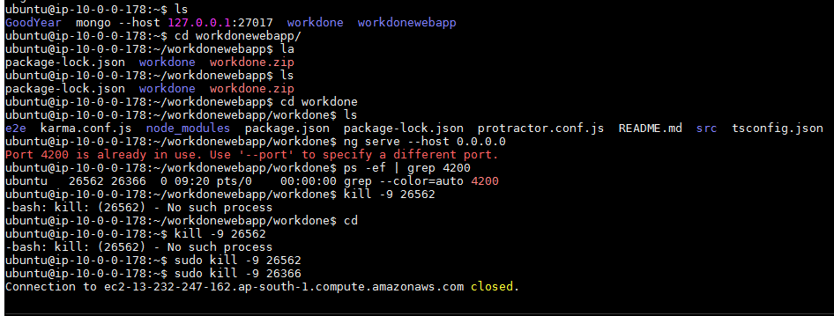
Finally we will check the link

http://13.232.247.162:4200/

user name :workdone
pwd :workdone@1234

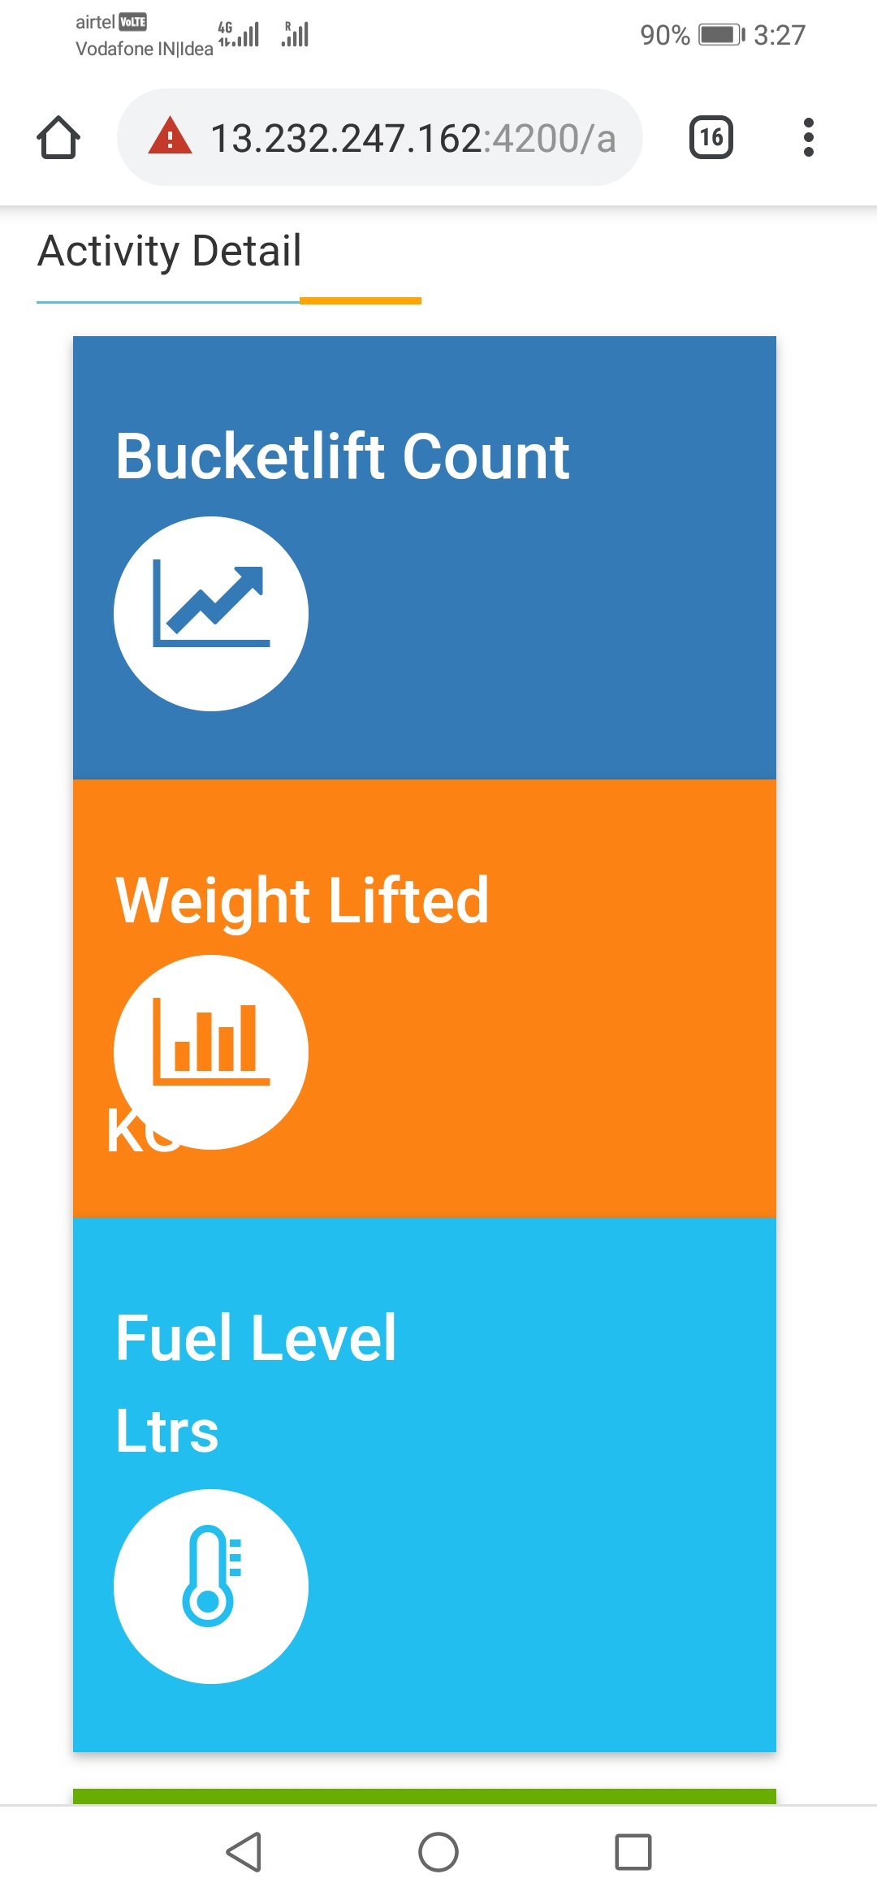

Back ground running commands for Application
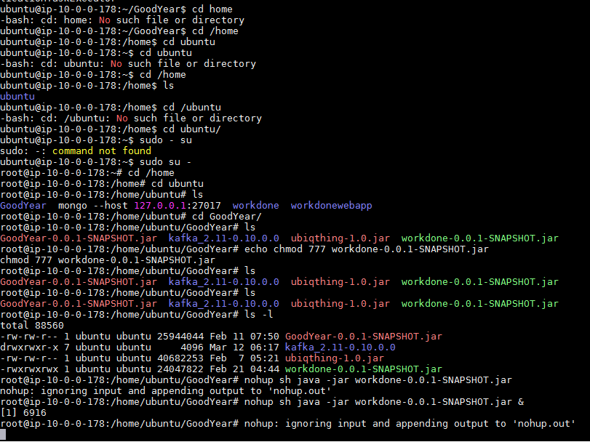

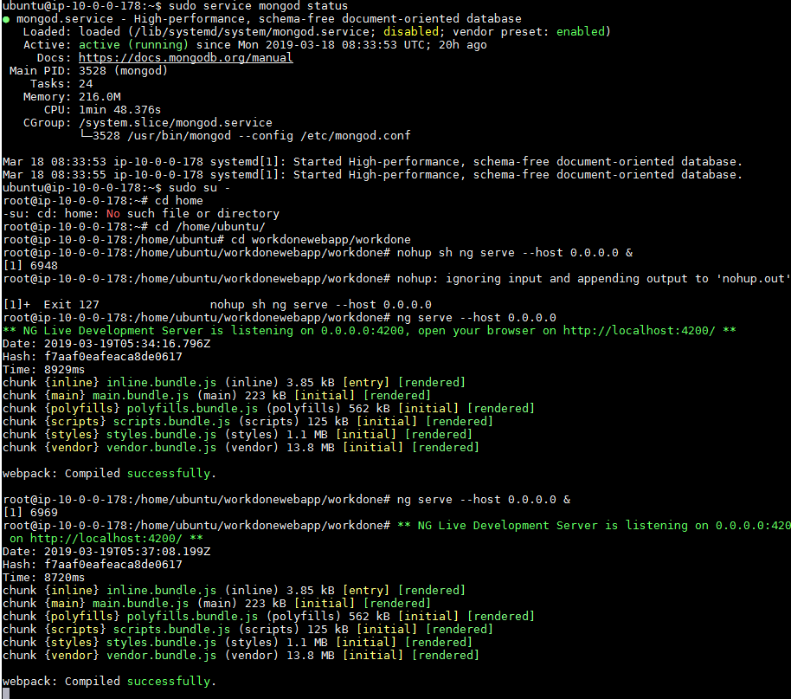

cd D:\PEMFILES

ssh -i "workdone.pem" ubuntu@ec2-13-232-247-162.ap-south-1.compute.amazonaws.com

ssh -i "workdone.pem" ubuntu@ec2-13-127-216-18.ap-south-1.compute.amazonaws.com

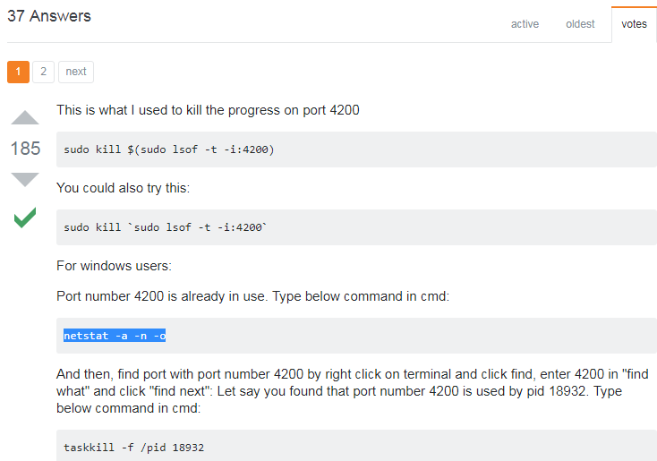

Java background run --Testing

nohup java -jar /web/server.jar &

sudo echo 'java -jar your_executable.jar' >> /etc/rc.local

https://www.mkyong.com/java/how-do-run-a-java-program-in-backgroud-unix-linux/

Final output for using Nohup for jar and ng serve



